**关于复星**

复星植根中国，深耕健康、快乐、富足领域，通过科技引领、持续创新，智造C2M（客户到智造者）幸福生态系统，为全球家庭客户提供高品质的产品和服务。复星创立于1992年，2007年复星国际在香港联交所主板上市（00656.HK）。截至2018年12月31日，复星国际总资产超过人民币6,388亿元（约931亿美元），位列2018福布斯全球上市公司2000强榜单第416位。

**2019复星【主打星】暑期实习生项目**

复星今年推出更多类型的校招岗位，通过暑期实习和星冉培训的机会，希望能够吸纳和招募更多年轻人才，发现和培养未来的集团领导者。

今年的实习岗位有投资金融，产品营销，AI科技，复星会提供为期约2个月的暑期实习机会，表现良好者可以优先申请今年9月的集团星冉项目。

星冉项目将持续一年。在这一年里，你将收获许多宝贵的跨专业知识，在快节奏的工作环境中迅速成长。你将拓展自己的金融财务/智能科技知识，提升市场分析能力，培养领导和沟通技能。

**点击下列网址申请 （申请截至日： 2019/5/17）：**

<http://fosun.zhaopin.com/>

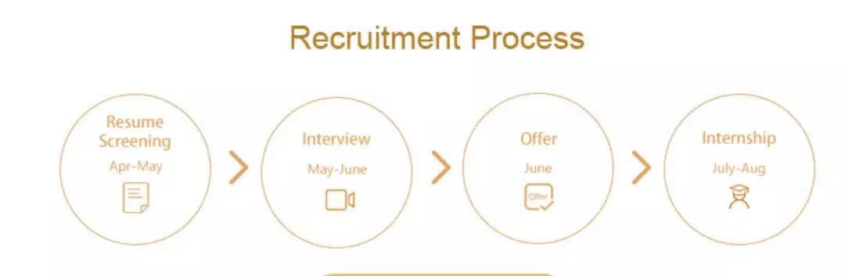

**扫描二维码，了解更多复星品牌故事：**



**暑期实习生职位介绍**

1. **Investment FOSTAR**

**Key Responsibilities:**

* Assist in deal origination and analysis throughout the investment process.
* Monitor market trends on a global scale; collect economic / marketing data and relevant third-party reports, establish investment frameworks etc.
* Investigate companies in both private and public sectors; support our teams in completing and submitting investment proposals.
* Ensure the content quality of professional materials (e.g. financial models, valuation analysis, due diligence, investment memorandums etc.).
* Assist senior executives and project leaders in negotiations and transaction processes.

**Requirements:**

* 2020 Bachelor/Master graduate. Internship experience in investment related fields and knowledge in Private Equity, Venture Capital, Equity Research, Investment Banking is highly preferred.
* Well-organized self-starter who is able to manage and prioritize a range of tasks.
* High proficiency in both Mandarin and English.

1. **AI FOSTAR**

**Key Responsibilities:**

Responsible for the research of in-depth learning algorithm for medical images, improve the ability of AI in disease detection, segmentation and prediction.

**Requirements:**

* Bachelor/Master of Computer/Biomedical Engineering/Medical Imaging;
* Basic knowledge of image processing and in-depth learning theory;
* Familiar with tensorflow/keras/pytorch framework, familiar with Python, have certain medical imaging basis is preferred;
* Have the keen observation, analysis and judgment ability, have the sense of responsibility and dedication, can efficiently complete the annotation task arranged every day;

1. **Marketing FOSTAR**

**Key Responsibilities:**

* Assist in analyzing the data of members’ consumption, summarizing methodologies and continuously optimizing operational strategies;
* Planning marketing activities for members, promoting the landing of explosive products.

**Requirements:**

* Bachelor degree or above, e-commerce/digital marketing related degree, clear logic thinking, strong data analysis and summary ability;
* Excellent communication and coordination skills, be able to maintain good communication and communication with others in cross-team cooperation, and can actively promote the progress of project.